Daniels fitness tracker

Daniels Fitness tracker works with adults 19-64 he gives each of his client an exercise goal to meet each week

# Task 1

# Requirements:

* Display a welcome message
* Ask the user for first name, last name, age, weight, height and email address
* Ask user for an exercise intensity level (high or moderate)
* Generate client ID (made up of the first 2 letters and the first 3 letters of the last name of the Client)
* Display the client details and ID and ask the user to confirm they are correct
* If User info is incorrect ask user to re-enter it then display the client details and id again
* Return to welcome message

# Flowchart

Start

Welcome message

NO

Ask User for exercise and intensity level (high or moderate)

Generate client ID

Ask User to input last name, first name, height and email

Display ID and ask user to confirm if correct

Yes

# Task 2

# Requirements:

* Must enter a number of minutes each client has spent exercising in one week
* Have clientintensity.txt and exerciseactivity.txt be used
* User instructions must be displayed
* Users must enter client ID and the client they wish to record results for
* Activity recorder must check the clients intensity level and display relevant activities
* Must enter the time spent between exercising limited to 0 – 120 minutes for each activities
* Client ID along with total time spent exercising in one week must then be displayed
* User must be asked if they wish to record activities for another client

# Task 3

# Requirements:

* Must give feedback to their clients
* Must use clientRecords.txt to search and sort to select and display clients progress
* Four choices must be displayed: Option A: Activity Summary for a client, Option B: Comparison of Client Progress, Option C: Top performing client, and Option Q:quit
* Option A must prompt for the client ID, must include exercise times for each activity, calculate total exercise time for selected client and displayed in this format

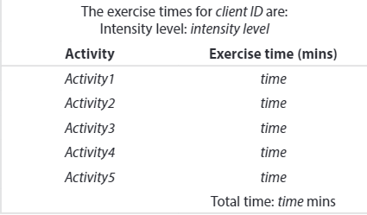

* 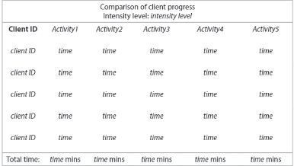Option B must provide a prompt for intensity level, then find the Client ID and exercise times for each activity based on intensity level, display total amount of time spent exercising and display in this format
* Option C must find the performing client for each intensity level, the top preforming client is the one who has exercised for the longest time, it must display the clients who have exercised the longest amount in each intensity level, if its more than one client than each client and their time should be dislayed, must display the amount of time each client has spent exercising, must be displayed in this format and the program must work for all records in the clientrecords.txt file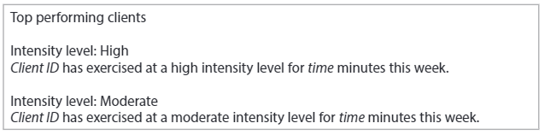

Daniels fitness tracker

Display clients who have exercised for the longest time and display the time each client spent excercising and display in a certain format

Display the amount of time spent exercising each client depending on intensity and display in the correct format

Calculate total excersize time for each activity and display in the correct format

Top performing client

Compare client progress

Activity summary for a client

Activity times

Relevant activities

Client ID

Generates client ID

Registering new client

Activity recorder

Feedback program